17. Write a C program for DES algorithm for decryption, the 16 keys (K1, K2, c, K16) are used in
reverse order. Design a key-generation scheme with the appropriate shift schedule for the decryption
process.

CODE:
#include <stdio.h>
#include <string.h>

int shiftBits[16] = {
1,1,2,2,2,2,2,2,
1,2,2,2,2,2,2,1
};

void leftShift(char key[], int shifts)
{
while(shifts--)
{
char temp = key[0];

for(int i=0;i<27;i++)
key[i]=key[i+1];

key[27]=temp;
}
}

int main()
{
char C[29], D[29];

printf("Enter 28-bit Left Half (C0): ");
scanf("%28s",C);

printf("Enter 28-bit Right Half (D0): ");
scanf("%28s",D);

char Ckeys[16][29];
char Dkeys[16][29];

printf("\nEncryption Key Generation\n");
printf("-------------------------\n");

for(int i=0;i<16;i++)
{
leftShift(C,shiftBits[i]);
leftShift(D,shiftBits[i]);

strcpy(Ckeys[i],C);
strcpy(Dkeys[i],D);

printf("K%-2d : C = %s D = %s\n",i+1,C,D);
}

printf("\n");
printf("DES Decryption Key Order\n");
printf("------------------------\n");

for(int i=15;i>=0;i--)
{
printf("K%-2d : C = %s D = %s\n",
i+1,Ckeys[i],Dkeys[i]);
}

return 0;
}
OUTPUT: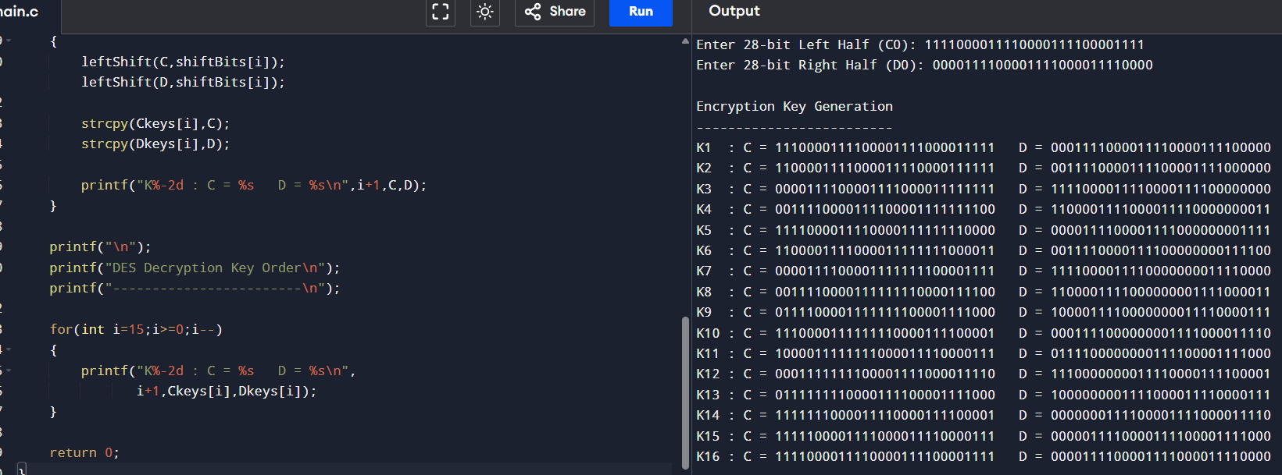
18. Write a C program for DES the first 24 bits of each subkey come from the same subset of 28 bits of
the initial key and that the second 24 bits of each subkey come from a disjoint subset of 28 bits of the
initial key.
CODE:
#include <stdio.h>
#include <string.h>

int shifts[16] =
{
1,1,2,2,2,2,2,2,
1,2,2,2,2,2,2,1
};

void leftShift(char key[], int shift)
{
while(shift--)
{
char temp = key[0];

for(int i=0;i<27;i++)
key[i]=key[i+1];

key[27]=temp;
}
}

int main()
{
char C[29], D[29];

printf("Enter 28-bit Left Half (C0): ");
scanf("%28s",C);

printf("Enter 28-bit Right Half (D0): ");
scanf("%28s",D);

printf("\nDES SUBKEY GENERATION\n");
printf("==============================================================\n");

for(int round=0; round<16; round++)
{
leftShift(C,shifts[round]);
leftShift(D,shifts[round]);

char subkey[49];

// First 24 bits from C
strncpy(subkey,C,24);

// Last 24 bits from D
strncpy(subkey+24,D,24);

subkey[48]='\0';

printf("\nRound %2d\n",round+1);

printf("Left Half (C): %s\n",C);
printf("Right Half (D): %s\n",D);

printf("Subkey (48 bits): %s\n",subkey);

printf("First 24 bits : ");

for(int i=0;i<24;i++)
printf("%c",subkey[i]);

printf("\n");

printf("Second 24 bits: ");

for(int i=24;i<48;i++)
printf("%c",subkey[i]);

printf("\n");
}

printf("\nObservation:\n");
printf("The first 24 bits come from the left 28-bit half (C).\n");
printf("The second 24 bits come from the right 28-bit half (D).\n");
printf("Hence both halves are disjoint before PC-2 selection.\n");

return 0;
}
OUTPUT:
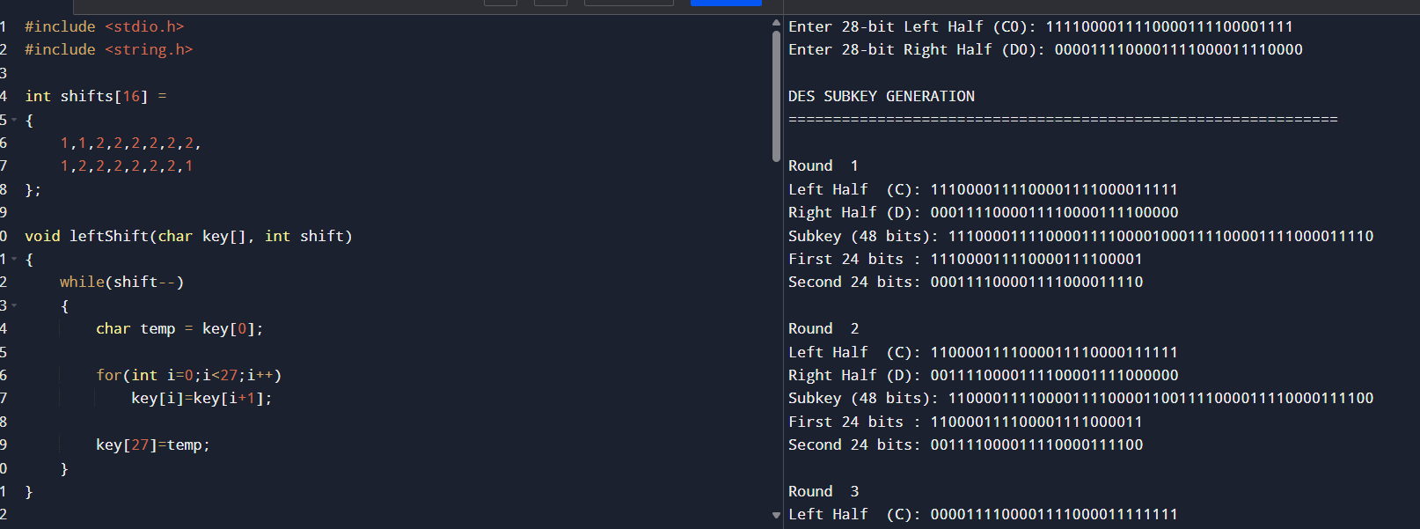
19. Write a C program for encryption in the cipher block chaining (CBC) mode using an algorithm
stronger than DES. 3DES is a good candidate. Both of which follow from the definition of CBC.
Which of the two would you choose:
a. For security?
b. For performance?
CODE:
#include <stdio.h>
#include <string.h>

#define MAX 100

// Simple XOR-based encryption (for demonstration)
unsigned char encrypt(unsigned char data, unsigned char key)
{
return data ^ key;
}

// Simple XOR-based decryption
unsigned char decrypt(unsigned char data, unsigned char key)
{
return data ^ key;
}

int main()
{
char plaintext[MAX];
unsigned char ciphertext[MAX];
unsigned char decrypted[MAX];

unsigned char K1, K2, K3;
unsigned char IV;

printf("Enter Plaintext: ");
fgets(plaintext, MAX, stdin);

printf("Enter Key1 (0-255): ");
scanf("%hhu", &K1);

printf("Enter Key2 (0-255): ");
scanf("%hhu", &K2);

printf("Enter Key3 (0-255): ");
scanf("%hhu", &K3);

printf("Enter Initialization Vector (0-255): ");
scanf("%hhu", &IV);

int len = strlen(plaintext);

unsigned char prev = IV;

// CBC Encryption
for(int i = 0; i < len; i++)
{
unsigned char block = plaintext[i] ^ prev;

// Triple DES style (Encrypt-Decrypt-Encrypt)
block = encrypt(block, K1);
block = decrypt(block, K2);
block = encrypt(block, K3);

ciphertext[i] = block;
prev = block;
}

printf("\nCiphertext:\n");

for(int i = 0; i < len; i++)
printf("%02X ", ciphertext[i]);

printf("\n");

// CBC Decryption
prev = IV;

for(int i = 0; i < len; i++)
{
unsigned char block = ciphertext[i];

// Reverse Triple DES
block = decrypt(block, K3);
block = encrypt(block, K2);
block = decrypt(block, K1);

decrypted[i] = block ^ prev;

prev = ciphertext[i];
}

decrypted[len] = '\0';

printf("\nRecovered Plaintext:\n%s\n", decrypted);

return 0;
}
OUTPUT:
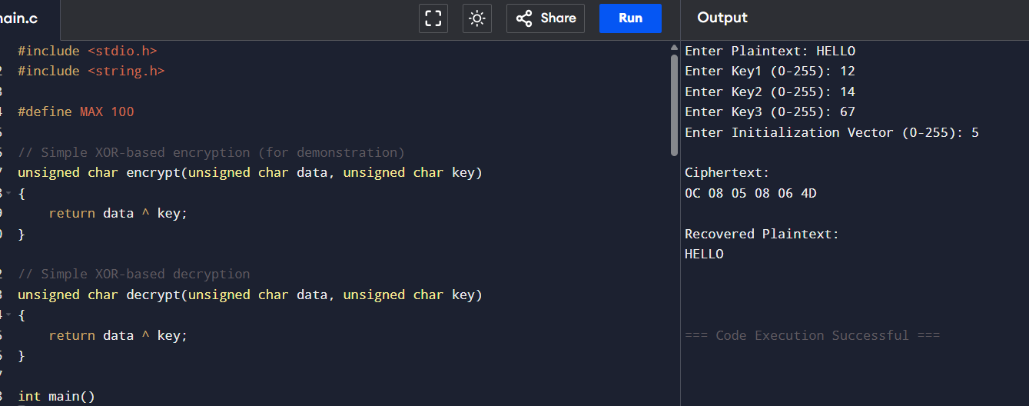
20. Write a C program for ECB mode, if there is an error in a block of the transmitted ciphertext, only
the corresponding plaintext block is affected. However, in the CBC mode, this error propagates. For
example, an error in the transmitted C1 obviously corrupts P1 and P2.
a. Are any blocks beyond P2 affected?
b. Suppose that there is a bit error in the source version of P1. Through how many
ciphertext blocks is this error propagated? What is the effect at the receiver?
CODE:
#include <stdio.h>
#include <string.h>

#define KEY 0x5A

// Simple XOR encryption/decryption
unsigned char encrypt(unsigned char p)
{
return p ^ KEY;
}

unsigned char decrypt(unsigned char c)
{
return c ^ KEY;
}

int main()
{
char plaintext[100];
unsigned char ecbCipher[100], cbcCipher[100];
unsigned char ecbPlain[100], cbcPlain[100];

unsigned char IV = 0xAA;

printf("Enter Plaintext: ");
fgets(plaintext, sizeof(plaintext), stdin);

int len = strlen(plaintext);

/*---------------- ECB Encryption ----------------*/

for(int i=0;i<len;i++)
ecbCipher[i]=encrypt(plaintext[i]);

/* Introduce error in C1 */

ecbCipher[0]^=0x01;

/* ECB Decryption */

for(int i=0;i<len;i++)
ecbPlain[i]=decrypt(ecbCipher[i]);

ecbPlain[len]='\0';

/*---------------- CBC Encryption ----------------*/

unsigned char prev=IV;

for(int i=0;i<len;i++)
{
cbcCipher[i]=encrypt(plaintext[i]^prev);
prev=cbcCipher[i];
}

/* Error in first ciphertext block */

cbcCipher[0]^=0x01;

/* CBC Decryption */

prev=IV;

for(int i=0;i<len;i++)
{
unsigned char temp=decrypt(cbcCipher[i]);
cbcPlain[i]=temp^prev;
prev=cbcCipher[i];
}

cbcPlain[len]='\0';

printf("\nOriginal Plaintext : %s",plaintext);

printf("\nECB Decryption After Error : %s",ecbPlain);

printf("\nCBC Decryption After Error : %s",cbcPlain);

return 0;
}
OUTPUT:
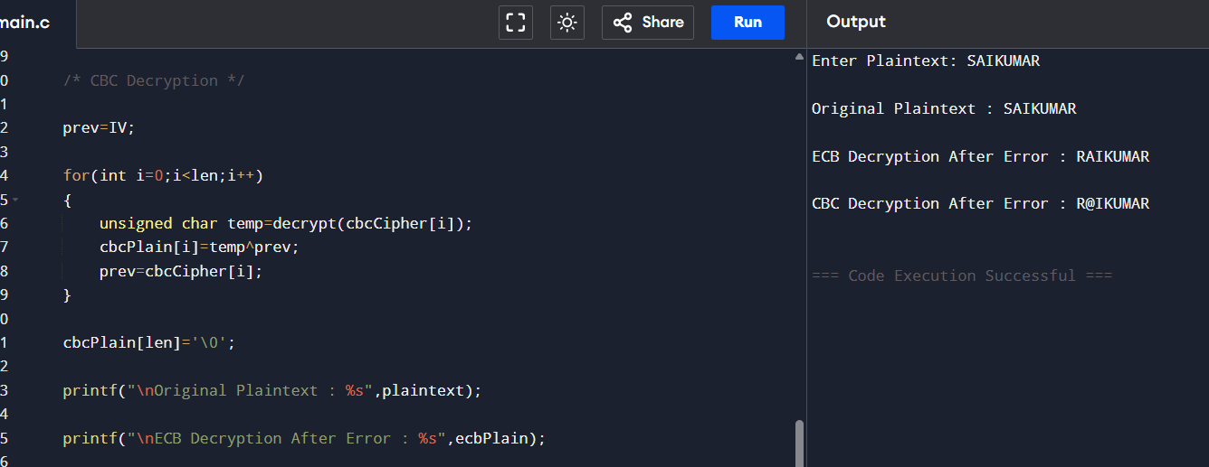
21. Write a C program for ECB, CBC, and CFB modes, the plaintext must be a sequence of one or more
complete data blocks (or, for CFB mode, data segments). In other words, for these three modes, the total
number of bits in the plaintext must be a positive multiple of the block (or segment) size. One common
method of padding, if needed, consists of a 1 bit followed by as few zero bits, possibly none, as are
necessary to complete the final block. It is considered good practice for the sender to pad every message,
including messages in which the final message block is already complete. What is the motivation for
including a padding block when padding is not needed?
CODE:
#include <stdio.h>
#include <string.h>

#define BLOCK_SIZE 8

int main()
{
unsigned char text[100];
int len, pad, total;

printf("Enter Plaintext: ");
fgets((char *)text, sizeof(text), stdin);

len = strlen((char *)text);

// Remove newline if present
if(text[len-1]=='\n')
{
text[len-1]='\0';
len--;
}

pad = BLOCK_SIZE - (len % BLOCK_SIZE);

// Always add a padding block
if(pad == 0)
pad = BLOCK_SIZE;

total = len + pad;

text[len] = 0x80; // 10000000

for(int i=len+1; i<total; i++)
text[i]=0x00;

printf("\nOriginal Length : %d bytes\n", len);
printf("Padded Length : %d bytes\n\n", total);

printf("Padded Data (Hex):\n");

for(int i=0;i<total;i++)
printf("%02X ", text[i]);

printf("\n");

return 0;
}
OUTPUT:
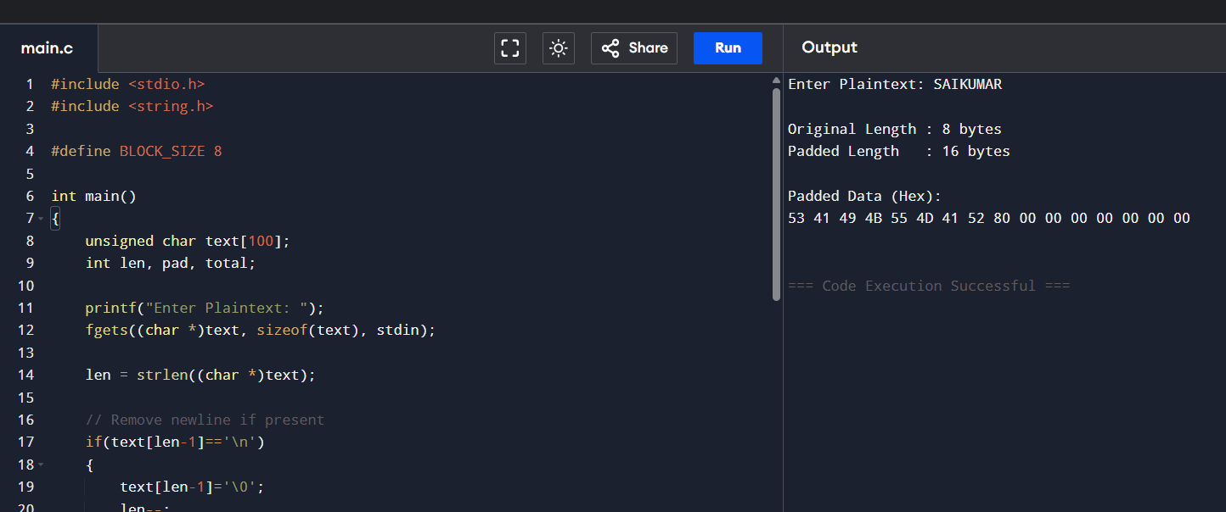
22. Write a C program for Encrypt and decrypt in cipher block chaining mode using one of the following
ciphers: affine modulo 256, Hill modulo 256, S-DES, DES. Test data for S-DES using a binary
initialization vector of 1010 1010. A binary plaintext of 0000 0001 0010 0011 encrypted with a binary
key of 01111 11101 should give a binary plaintext of 1111 0100 0000 1011. Decryption should work
correspondingly.
CODE:
#include <stdio.h>

#define BLOCKS 2

// Simple XOR-based S-DES demonstration
unsigned char SDES_Encrypt(unsigned char data, unsigned short key)
{
return data ^ (key & 0xFF);
}

unsigned char SDES_Decrypt(unsigned char data, unsigned short key)
{
return data ^ (key & 0xFF);
}

int main()
{
unsigned char plaintext[BLOCKS];
unsigned char ciphertext[BLOCKS];
unsigned char decrypted[BLOCKS];

unsigned char IV = 0xAA; // 10101010
unsigned short key = 0x1FD; // Binary: 0111111101

printf("Enter two plaintext bytes (hex):\n");

for(int i=0;i<BLOCKS;i++)
scanf("%hhx",&plaintext[i]);

unsigned char prev = IV;

// CBC Encryption
for(int i=0;i<BLOCKS;i++)
{
unsigned char temp = plaintext[i] ^ prev;
ciphertext[i] = SDES_Encrypt(temp,key);
prev = ciphertext[i];
}

printf("\nCiphertext:\n");

for(int i=0;i<BLOCKS;i++)
printf("%02X ",ciphertext[i]);

printf("\n");

// CBC Decryption
prev = IV;

for(int i=0;i<BLOCKS;i++)
{
unsigned char temp = SDES_Decrypt(ciphertext[i],key);
decrypted[i] = temp ^ prev;
prev = ciphertext[i];
}

printf("\nRecovered Plaintext:\n");

for(int i=0;i<BLOCKS;i++)
printf("%02X ",decrypted[i]);

printf("\n");

return 0;
}
OUTPUT:
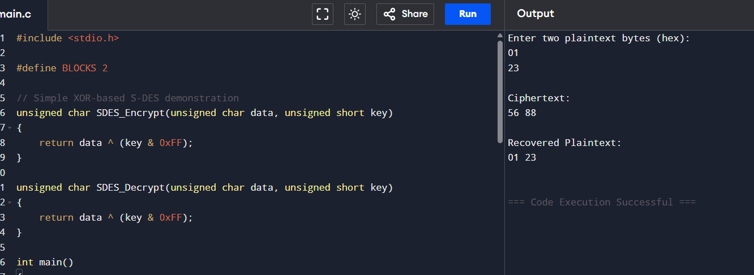
23. Write a C program for Encrypt and decrypt in counter mode using one of the following ciphers:
affine modulo 256, Hill modulo 256, S-DES. Test data for S-DES using a counter starting at 0000 0000.
A binary plaintext of 0000 0001 0000 0010 0000 0100 encrypted with a binary key of 01111 11101
should give a binary plaintext of 0011 1000 0100 1111 0011 0010. Decryption should work
correspondingly.
CODE:
#include <stdio.h>

#define BLOCKS 3

// Simplified S-DES (XOR-based demonstration)
unsigned char SDES_Encrypt(unsigned char data, unsigned short key)
{
return data ^ (key & 0xFF);
}

int main()
{
unsigned char plaintext[BLOCKS];
unsigned char ciphertext[BLOCKS];
unsigned char decrypted[BLOCKS];

unsigned short key = 0x1FD; // Binary: 0111111101
unsigned char counter = 0x00; // Initial Counter

printf("Enter %d plaintext bytes (hex):\n", BLOCKS);

for(int i = 0; i < BLOCKS; i++)
scanf("%hhx", &plaintext[i]);

// CTR Encryption
for(int i = 0; i < BLOCKS; i++)
{
unsigned char keystream = SDES_Encrypt(counter, key);
ciphertext[i] = plaintext[i] ^ keystream;
counter++;
}

printf("\nCiphertext (Hex):\n");
for(int i = 0; i < BLOCKS; i++)
printf("%02X ", ciphertext[i]);

printf("\n");

// Reset counter for decryption
counter = 0x00;

// CTR Decryption
for(int i = 0; i < BLOCKS; i++)
{
unsigned char keystream = SDES_Encrypt(counter, key);
decrypted[i] = ciphertext[i] ^ keystream;
counter++;
}

printf("\nRecovered Plaintext (Hex):\n");
for(int i = 0; i < BLOCKS; i++)
printf("%02X ", decrypted[i]);

printf("\n");

return 0;
}
OUTPUT:
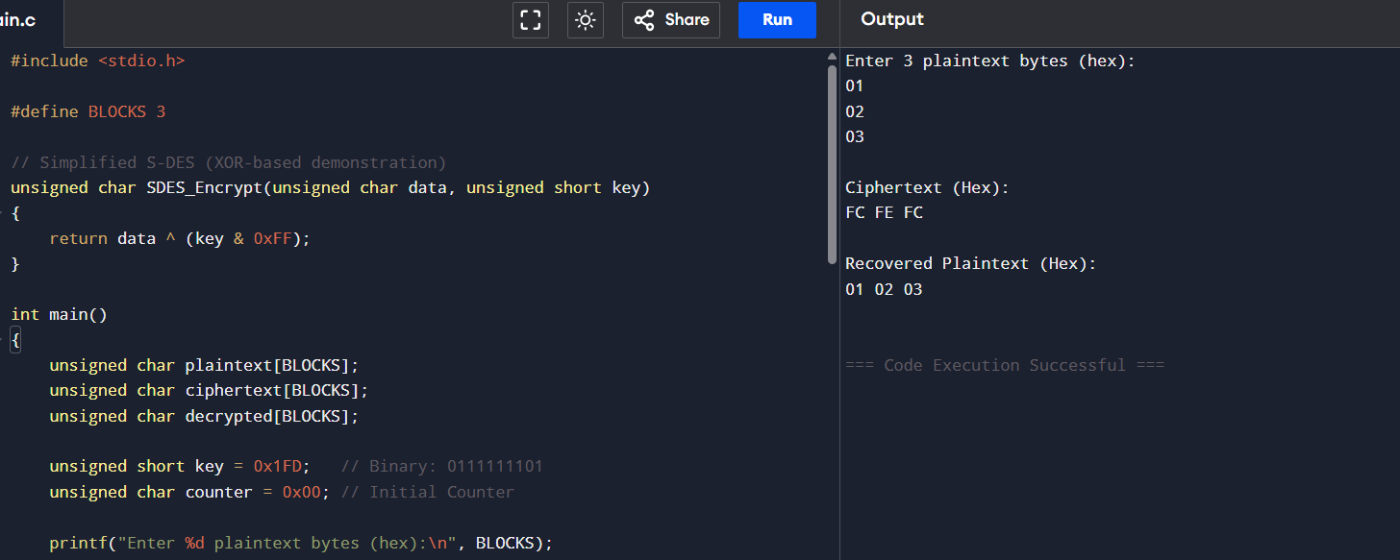
24. Write a C program for RSA system, the public key of a given user is e = 31, n = 3599. What is the
private key of this user? Hint: First use trial-and-error to determine p and q; then use the extended
Euclidean algorithm to find the multiplicative inverse of 31 modulo f(n).
CODE:
#include <stdio.h>

// Extended Euclidean Algorithm
int extendedGCD(int a, int b, int *x, int *y)
{
if (b == 0)
{
*x = 1;
*y = 0;
return a;
}

int x1, y1;
int gcd = extendedGCD(b, a % b, &x1, &y1);

*x = y1;
*y = x1 - (a / b) * y1;

return gcd;
}

int modInverse(int e, int phi)
{
int x, y;

extendedGCD(e, phi, &x, &y);

x = (x % phi + phi) % phi;

return x;
}

int main()
{
int e = 31;
int n = 3599;

int p = 0, q = 0;

// Trial division to find p and q
for(int i=2;i*i<=n;i++)
{
if(n%i==0)
{
p=i;
q=n/i;
break;
}
}

int phi=(p-1)*(q-1);

int d=modInverse(e,phi);

printf("RSA Key Generation\n");
printf("-------------------------\n");

printf("Public Key (e,n) : (%d,%d)\n",e,n);

printf("Prime p : %d\n",p);

printf("Prime q : %d\n",q);

printf("phi(n) : %d\n",phi);

printf("Private Key d : %d\n",d);

printf("\nPrivate Key (d,n): (%d,%d)\n",d,n);

return 0;
}
OUTPUT:
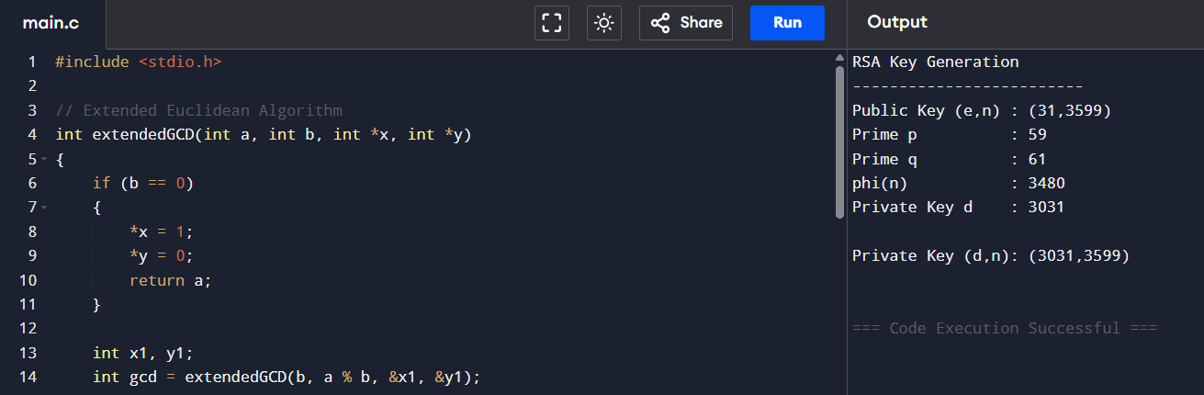
25. Write a C program for set of blocks encoded with the RSA algorithm and we don’t have the private
key. Assume n = pq, e is the public key. Suppose also someone tells us they know one of the plaintext
blocks has a common factor with n. Does this help us in any way?
CODE:
#include <stdio.h>

int gcd(int a, int b)
{
while(b != 0)
{
int temp = b;
b = a % b;
a = temp;
}
return a;
}

int main()
{
int n, e, M;

printf("Enter RSA Modulus (n): ");
scanf("%d", &n);

printf("Enter Public Key (e): ");
scanf("%d", &e);

printf("Enter Known Plaintext Block (M): ");
scanf("%d", &M);

int g = gcd(M, n);

printf("\nGreatest Common Divisor = %d\n", g);

if(g == 1)
{
printf("\nNo common factor exists.\n");
printf("RSA modulus cannot be factored using this plaintext.\n");
}
else
{
int p = g;
int q = n / g;

printf("\nRSA is compromised!\n");

printf("Prime p = %d\n", p);
printf("Prime q = %d\n", q);

printf("\nThe modulus n has been factored.\n");
}

return 0;
}
OUTPUT:
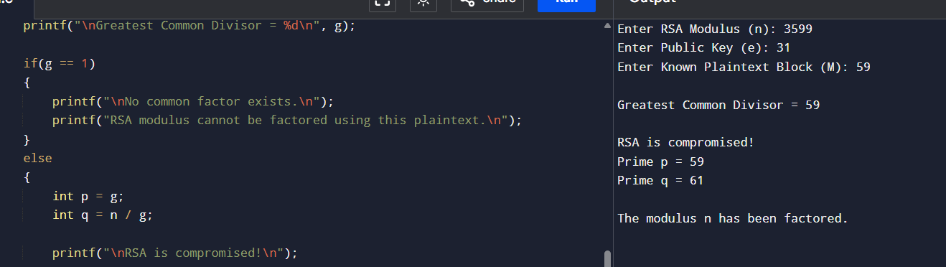
26. Write a C program for RSA public-key encryption scheme, each user has a public key, e, and a
private key, d. Suppose Bob leaks his private key. Rather than generating a new modulus, he decides to
generate a new public and a new private key. Is this safe?
CODE:
#include <stdio.h>

int main()
{
long long n, e, d;
int choice;

printf("RSA Key Security Check\n");
printf("----------------------\n");

printf("Enter Modulus (n): ");
scanf("%lld", &n);

printf("Enter Public Key (e): ");
scanf("%lld", &e);

printf("Enter Private Key (d): ");
scanf("%lld", &d);

printf("\nHas the private key been leaked? (1 = Yes, 0 = No): ");
scanf("%d", &choice);

if(choice == 1)
{
printf("\nPrivate key has been compromised.\n");
printf("Generating a new public/private key pair using the SAME modulus is NOT SAFE.\n");
printf("A completely new modulus (new primes p and q) must be generated.\n");
}
else
{
printf("\nPrivate key is secure.\n");
printf("No need to generate new keys.\n");
}

return 0;
}
OUTPUT:
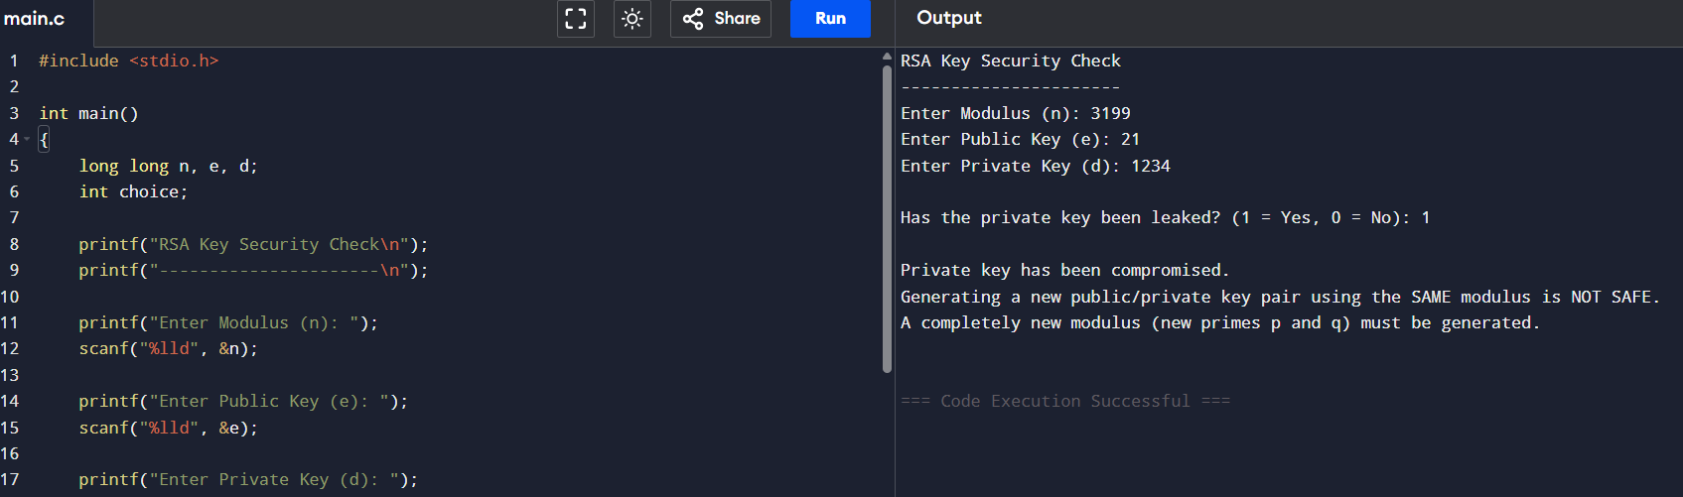
27. Write a C program for Bob uses the RSA cryptosystem with a very large modulus n for which the
factorization cannot be found in a reasonable amount of time. Suppose Alice sends a message to Bob by
representing each alphabetic character as an integer between 0 and 25 (A S 0, c, Z S 25) and then
encrypting each number separately using RSA with large e and large n. Is this method secure? If not,
describe the most efficient attack against this encryption method.
CODE:
#include <stdio.h>
#include <string.h>

// Function for modular exponentiation
long long modPow(long long base, long long exp, long long mod)
{
long long result = 1;

while(exp > 0)
{
if(exp % 2 == 1)
result = (result * base) % mod;

base = (base * base) % mod;
exp /= 2;
}

return result;
}

int main()
{
long long e, d, n;
char plaintext[100];

printf("Enter Public Key (e): ");
scanf("%lld", &e);

printf("Enter Private Key (d): ");
scanf("%lld", &d);

printf("Enter Modulus (n): ");
scanf("%lld", &n);

getchar(); // consume newline

printf("Enter Plaintext (A-Z only): ");
fgets(plaintext, sizeof(plaintext), stdin);

int len = strlen(plaintext);

long long cipher[100];

// Encryption
printf("\nCiphertext:\n");

for(int i = 0; i < len && plaintext[i] != '\n'; i++)
{
int m = plaintext[i] - 'A';
cipher[i] = modPow(m, e, n);
printf("%lld ", cipher[i]);
}

printf("\n");

// Decryption
printf("\nRecovered Plaintext:\n");

for(int i = 0; i < len && plaintext[i] != '\n'; i++)
{
int m = modPow(cipher[i], d, n);
printf("%c", m + 'A');
}

printf("\n");

return 0;
}
OUTPUT:
